The Basics of Participant Support Costs

Who is a participant?
A participant is defined as a non-RU employee who is the recipient, not the provider, of a service or training associated with a workshop, conference, seminar, symposium or other short-term instructional or information sharing activity. Participants do not perform work or services for the project or program unless it is for their own benefit. Participants may include students, scholars, and scientists from other institutions, representatives from the private sector, teachers, and state or local government agency personnel.

What does not qualify as participant support costs
- Honoraria – guest speaker at a conference, symposium or workshop
- Human Subjects - Incentive payments to encourage individuals to participate in research study and provide private data/information through intervention or interaction. This includes participation in surveys and interviews.
- Fellowships – financial support for a postdoctoral fellow to do things such as attend conferences or workshops
- RU employees (faculty, staff, and student employee on the award)
- General collaborator including non-RU co-PIs
- Project organizer, consultant, facilitator, or coordinator of the workshop, conference, training session
- Speaker (unless the majority of time is spent as a participant and not a speaker)
- Rental fees, catering and general supplies

Participant Incentives
The Uniform Guidelines defines Participant Incentives as payments to individuals to motivate them to take advantage of grant-supported health care or other services are allowable if within the scope of an approved project.

Facilities and Administrative Costs (F&A) on Participant Support vs Participant Incentives
Participant support costs are F&A excludable and should be explicitly listed in the proposal budget and budget justification.
Participant Incentives are NOT excludable from F&A and should be entered on the budget under Other Costs

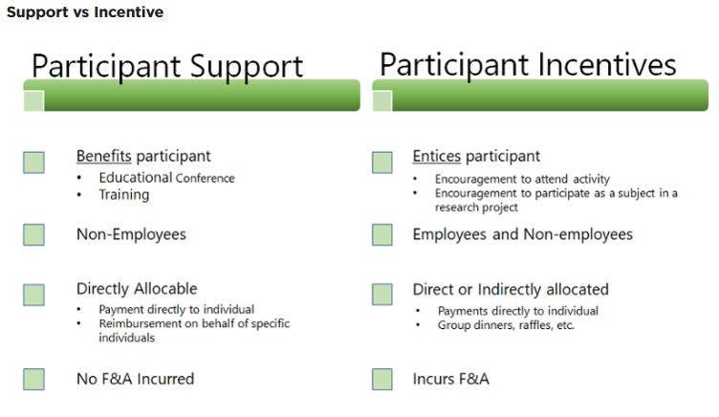

NSF PAPPG: https://www.nsf.gov/pubs/policydocs/pappg19_1/pappg_2.jsp#IIC2gv

(v) Participant Support (Line F on the Proposal Budget) This budget category refers to direct costs for items such as stipends or subsistence allowances, travel allowances, and registration fees paid to or on behalf of participants or trainees (but not employees) in connection with NSF-sponsored conferences or training projects. Any additional categories of participant support costs other than those described in 2 CFR § 200.75 (such as incentives, gifts, souvenirs, t-shirts and memorabilia), must be justified in the budget justification, and such costs will be closely scrutinized by NSF. (See Chapter II.E.7). Speakers and trainers generally are not considered participants and should not be included in this section of the budget. However, if the primary purpose of the individual’s attendance at the conference is learning and receiving training as a participant, then the costs may be included under participant support. If the primary purpose is to speak or assist with management of the conference, then such costs should be budgeted in appropriate categories other than participant support.
For some educational projects conducted at local school districts, the participants being trained are employees. In such cases, the costs must be classified as participant support if payment is made through a stipend or training allowance method. The school district must have an accounting mechanism in place (i.e., sub-account code) to differentiate between regular salary and stipend payments.
To help defray the costs of participating in a conference or training activity, funds may be proposed for payment of stipends, per diem or subsistence allowances, based on the type and duration of the activity. Such allowances must be reasonable, in conformance with the policy of the proposing organization and limited to the days of attendance at the conference plus the actual travel time required to reach the conference location. Where meals or lodgings are furnished without charge or at a nominal cost (e.g., as part of the registration fee), the per diem or subsistence allowance should be correspondingly reduced. Although local participants may participate in conference meals and coffee breaks, funds may not be proposed to pay per diem or similar expenses for local participants in the conference. Participant support costs may not be budgeted to cover room rental fees, catering costs, supplies, etc. related to an NSF-sponsored conference. This section of the budget also may not be used for incentive payments to research subjects. Human subject payments should be included on line G6 of the NSF budget under "Other Direct Costs," and any applicable indirect costs should be calculated on the payments in accordance with the organization’s federally negotiated indirect cost rate.
Funds may be requested for the travel costs of participants. If so, the restrictions regarding class of accommodations and use of U.S.-Flag air carriers are applicable.¹⁹ In training activities that involve field trips, costs of transportation of participants are allowable. The number of participants to be supported must be entered in the parentheses on the proposal budget. Participant support costs must be specified, itemized and justified in the budget justification section of the proposal. Indirect costs (F&A) are not usually allowed on participant support costs unless the grantee’s current, federally approved indirect cost rate agreement provides for allocation of F&A to participant support costs. Participant support costs must be accounted for separately should an award be made.

